Project Documentation: Import Data using Transform Maps (Spreadsheet)
Oct 3, 2026 · @siva
Team ID: SWTID-2026-5226 · Date: 3 OCTOBER 2026

1. Introduction
Project Title: Import Data using Transform Maps (Spreadsheet)
Team Members:
Team member | Role (stories owned)
Monika R | Creation of Spreadsheet
Priyanka D | Creation of Tables; Transform Data & Validate
Archana R K | Create Import Set Table; Create Transform Map
Nithyasree M | Enable Coalesce to Avoid Duplicate Records
Pushpavalli B | Inserting New Data in Excel Format; Report 1

2. Project Overview
Purpose: Spreadsheet data is uploaded into a ServiceNow Import Set table, then validated and transformed with a Transform Map before it is inserted or updated in the target Employee Test table. Reports on that table show the result.
Features:
- Spreadsheet (.xlsx) upload through Load Data into the Employee Import staging table.
- Custom target table Employee Test with five String fields: Employee ID, Employee Name, Email, Department, Location.
- Transform Map with Auto Map Matching Fields from source to target.
- Coalesce on Employee ID, so repeated imports update existing records instead of creating duplicates.
- Transform History showing Total, Inserted, Updated and Ignored counts for every run.
- Reports and a dashboard on employee data, starting with Employees by Department (pie chart).

3. Architecture
The project replaces the React, Node.js and MongoDB layers with ServiceNow's own import tools: a spreadsheet as input, an import set and transform map for processing, and a custom table as the data store.
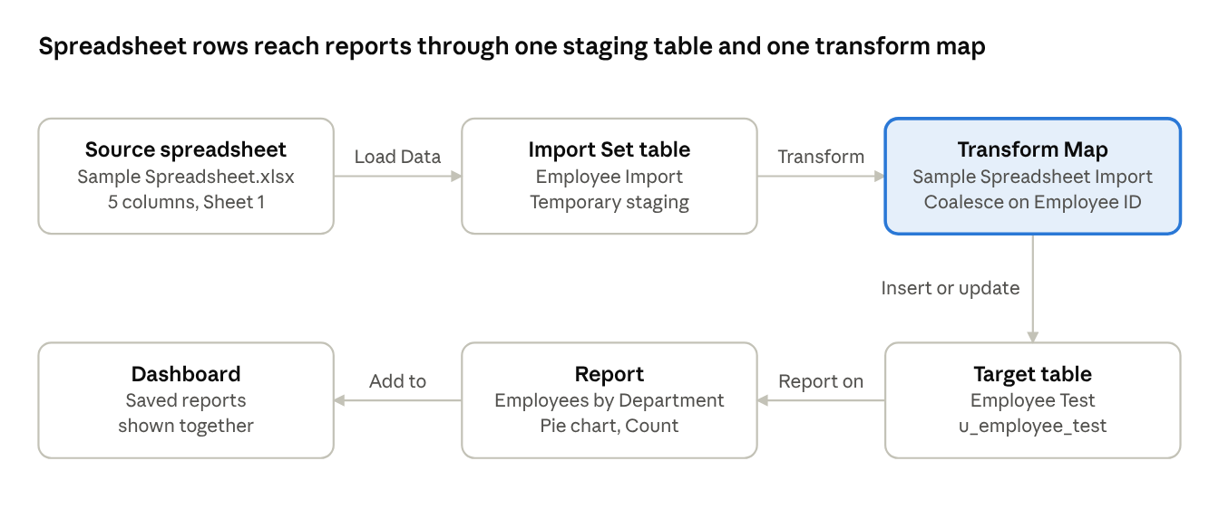
import flow · 6 stages
Rows move from the spreadsheet into staging, are mapped and coalesced by the transform map, land in Employee Test, then feed the report and dashboard.
Frontend (source and interface): The input is the .xlsx file prepared in Google Sheets. Users work in the ServiceNow interface: Load Data, Transform Maps, the Employee Test list, Reports and dashboards.
Backend (processing): The Employee Import table stores uploaded rows. The Sample Spreadsheet Import transform map moves them to Employee Test, with Coalesce on Employee ID so existing records are updated and new IDs are inserted.
Database (schema): Employee Test (u_employee_test) holds the final records. Employee Import has the same five columns.
Field | Type | Notes
Employee ID | String | Coalesce field
Employee Name | String
Email | String | Required to be valid during validation
Department | String | Used to group the report
Location | String

4. Setup Instructions
Prerequisites:
- A ServiceNow instance where you can open Tables, Load Data, Transform Maps and Reports.
- A Google account for Google Sheets, or Excel, to prepare the .xlsx file.
- A browser such as Chrome.
Installation (configuration steps):
- Open a new Google Sheet and enter sample data with the columns Employee ID, Name, Email, Department, Location.
- Download it as Microsoft Excel (.xlsx) and save it as Sample Spreadsheet.xlsx.
- In ServiceNow, go to Tables > Create New. Set Label to Employee Test and Name to u_employee_test, then save.
- Open the form, then Form Context Menu > Configure > Form Layout. Add Employee ID, Employee Name, Email, Department and Location, all of type String, and save.
- Go to Load Data and create the import set table. Set Label to Employee Import (Name u_employee_import is filled in automatically).
- Choose the Excel file, set Sheet number 1 and Header row 1, then Submit.
- After the success message, click Create Transform Map. Set Name to Sample Spreadsheet Import, Source to Employee Import and Target to Employee Test.
- Click Auto Map Matching Fields, save, and check that source and target fields are mapped.
No environment variables are needed; everything is configured inside the ServiceNow instance.

5. Folder Structure
ServiceNow has no code folders, so this section lists the objects the project creates, grouped by role in the flow.
Part | Object | Name | Purpose
Source (Client side) | Spreadsheet | Sample Spreadsheet.xlsx | Holds the employee rows to import
Staging (Server side) | Import Set table | Employee Import (u_employee_import) | Temporary storage for uploaded rows
Staging (Server side) | Transform Map | Sample Spreadsheet Import | Maps source fields to target fields; Coalesce on one unique field
Target (Server side) | Custom table | Employee Test (u_employee_test) | Final employee records
Output | Report | Employees by Department | Pie chart, grouped by Department, aggregated by Count
Output | Dashboard | Dashboard with the saved reports | Shows the saved reports together

6. Running the Application
There is no frontend or backend server to start. The import runs from inside ServiceNow:
- Open All menus > System Import Sets > Load Data.
- Choose Existing table (Employee Import) as the import set table and File as the source. Select the .xlsx file, Sheet number 1, Header row 1, then click Submit.
- Wait for State Completed and Success.
- Click Run Transform under the next steps. Pick the Sample Spreadsheet Import transform map and click Transform.
- Open Transform History to see how many rows were inserted, updated or ignored.
- Open the Employee Test table to see the records.

7. API Documentation
The project exposes no custom REST endpoints. It uses ServiceNow's built-in modules, listed below in the order they are called.
Module | Navigation | Input | Result
Tables | Tables > Create New | Label Employee Test, Name u_employee_test | Target table created
Load Data | All menus > System Import Sets > Load Data | .xlsx file, Sheet number 1, Header row 1 | Rows stored in Employee Import; green Success message
Transform Maps | System Import Sets > Transform Maps | Source Employee Import, Target Employee Test, Coalesce on Employee ID | Field mappings saved
Run Transform | Transform link on the import result | Import set and transform map | State Completed and Success; rows in Employee Test
Transform History | System Import Sets > Transform History | None | Counts of Total, Inserted, Updated, Ignored
Reports | All menus > Reports > New | Table Employee Test, Pie chart, Group by Department, Count | Saved report
Example result of the second import (4 rows, 2 existing IDs changed, 2 new IDs): Total 4, Inserted 2, Updated 2.

8. Authentication
The project does not add its own login. Work is done by signing in to the ServiceNow instance with a user account that can open Tables, Load Data, Transform Maps and Reports. The project tracking itself sits in the SkillWallet workspace, where each story is assigned to one team member.
Open question: which ServiceNow role did the team use (for example admin)? Add it here.

10. Testing
Testing was manual, using ServiceNow's own result screens: the success banner after each load and run, the Transform History counts, and the Employee Test list view.
Test | Steps | Expected and observed result
First import | Load the sample .xlsx, then run the transform | All records appear in Employee Test; state Completed and Success
Field mapping | Open the Field Maps list | Source and target fields are mapped for all five columns
Insert and update | Load 4 rows: 2 existing IDs with a changed name or email, 2 new IDs; run the transform | Total 4, Inserted 2, Updated 2; Employee Test shows the changes
Duplicate check | Load the same file again and run the transform | Inserted 0, Updated 0, Ignored 4; no duplicates

12. Known Issues
- Coalesce is false by default, so duplicates are possible until it is set on a unique field.
- The transform must be run again by hand after each new load.
- Imported columns can arrive in an unexpected order and need Personalize List Columns.
- An Ignored count of 4 can look like a failure to someone new; it means the data already exists unchanged.
- Only Report 1 (Employees by Department) is documented here; the other reports and the dashboard contents are not shown in the project screenshots.

13. Future Enhancements
- Schedule imports, or run the transform automatically after each load.
- Add data validation to the spreadsheet (for example email format) before upload.
- Email the admin when a transform finishes or reports errors.
- Add more report types (such as employees by location) and dashboard filters.
- Reuse a table template so new fields are not added one by one.
- Add a plain-language note explaining Inserted, Updated and Ignored.

